Lab 1: File and Directory Management

Objective: Practice basic file and directory management commands.

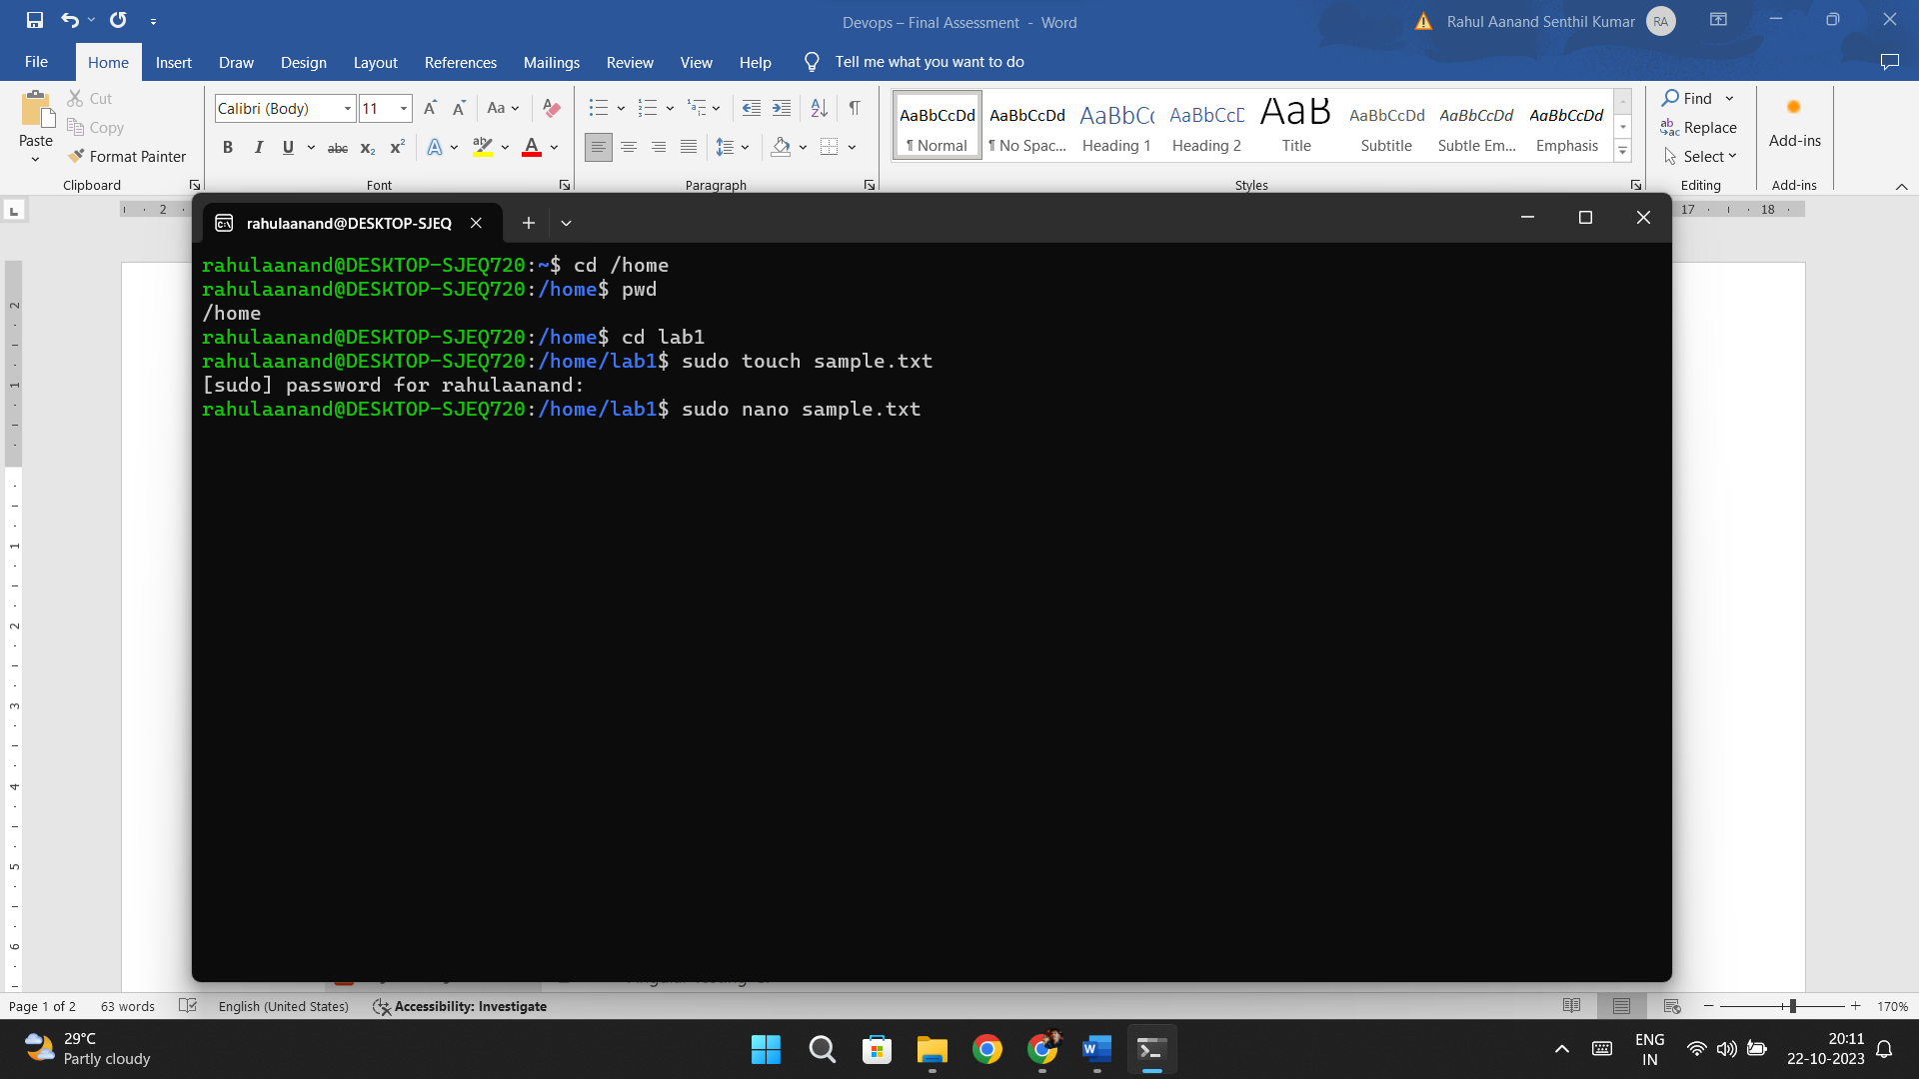

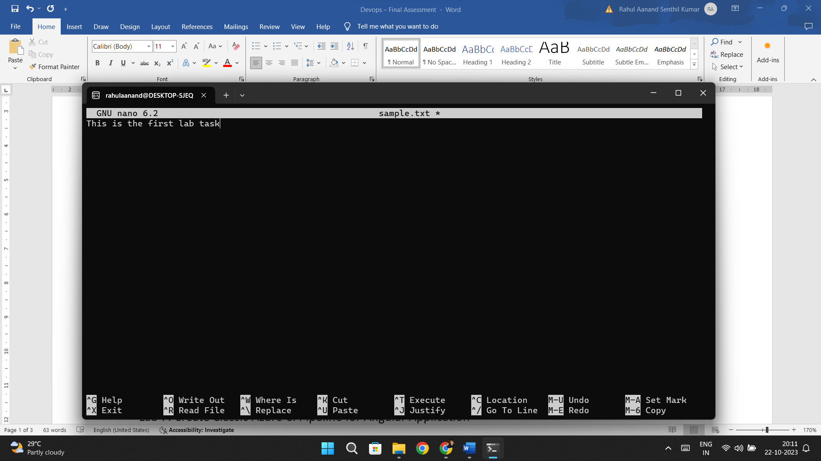

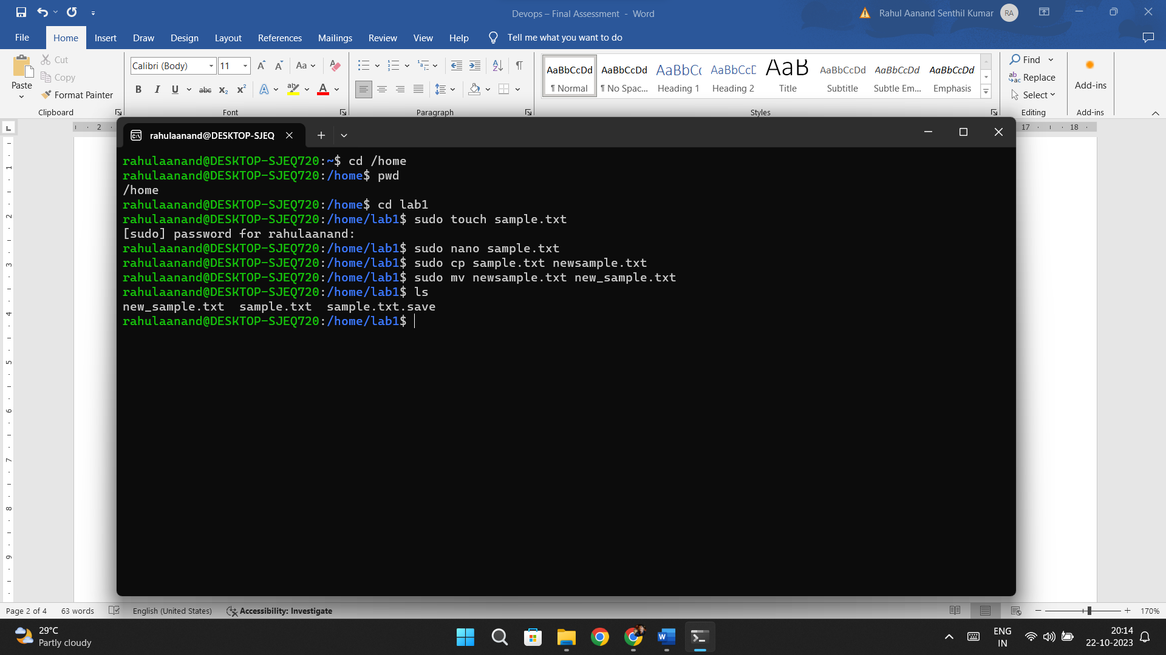

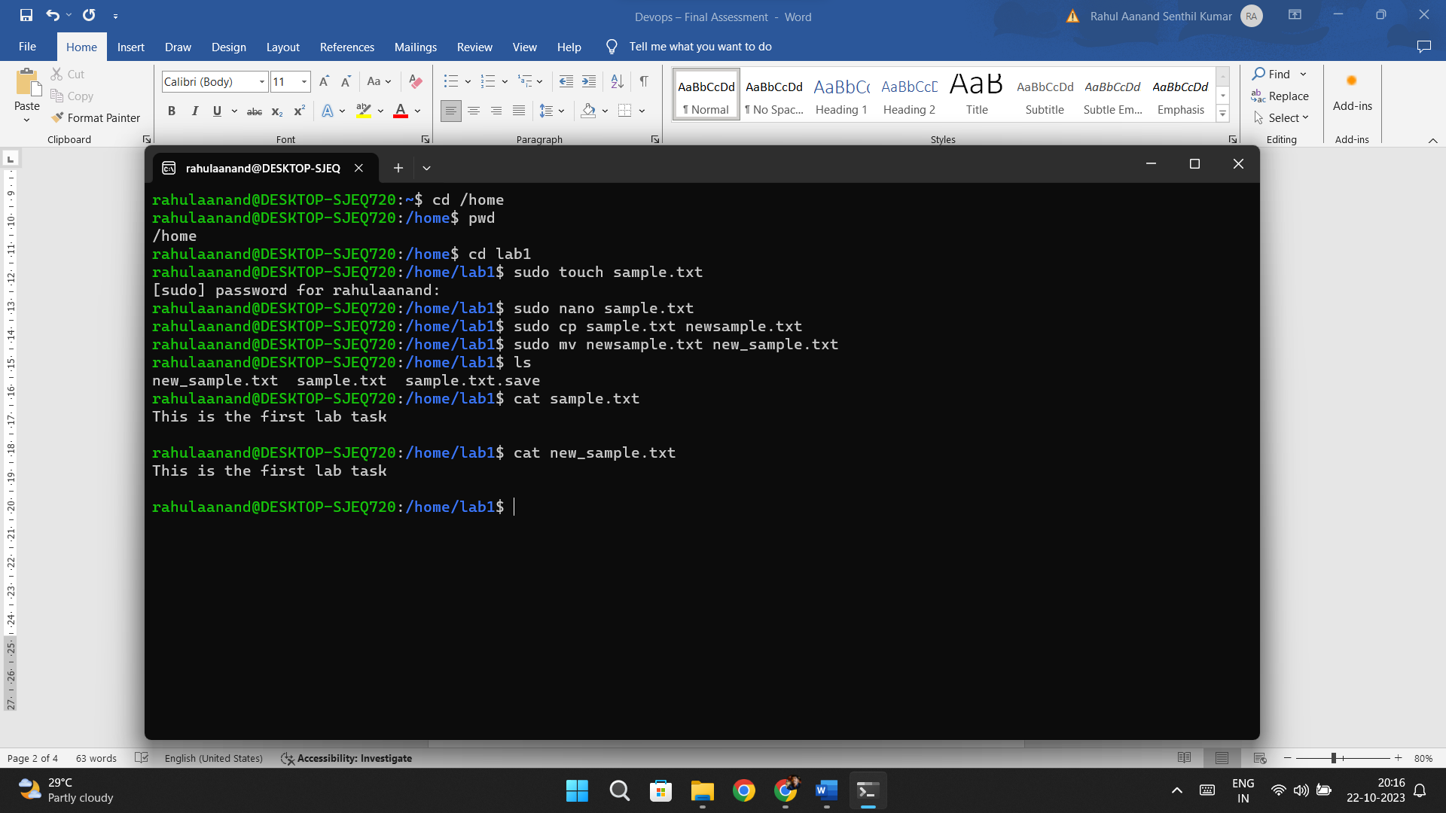

Lab 2: Permissions and Ownership

Objective: Understand and manage file permissions and ownership.

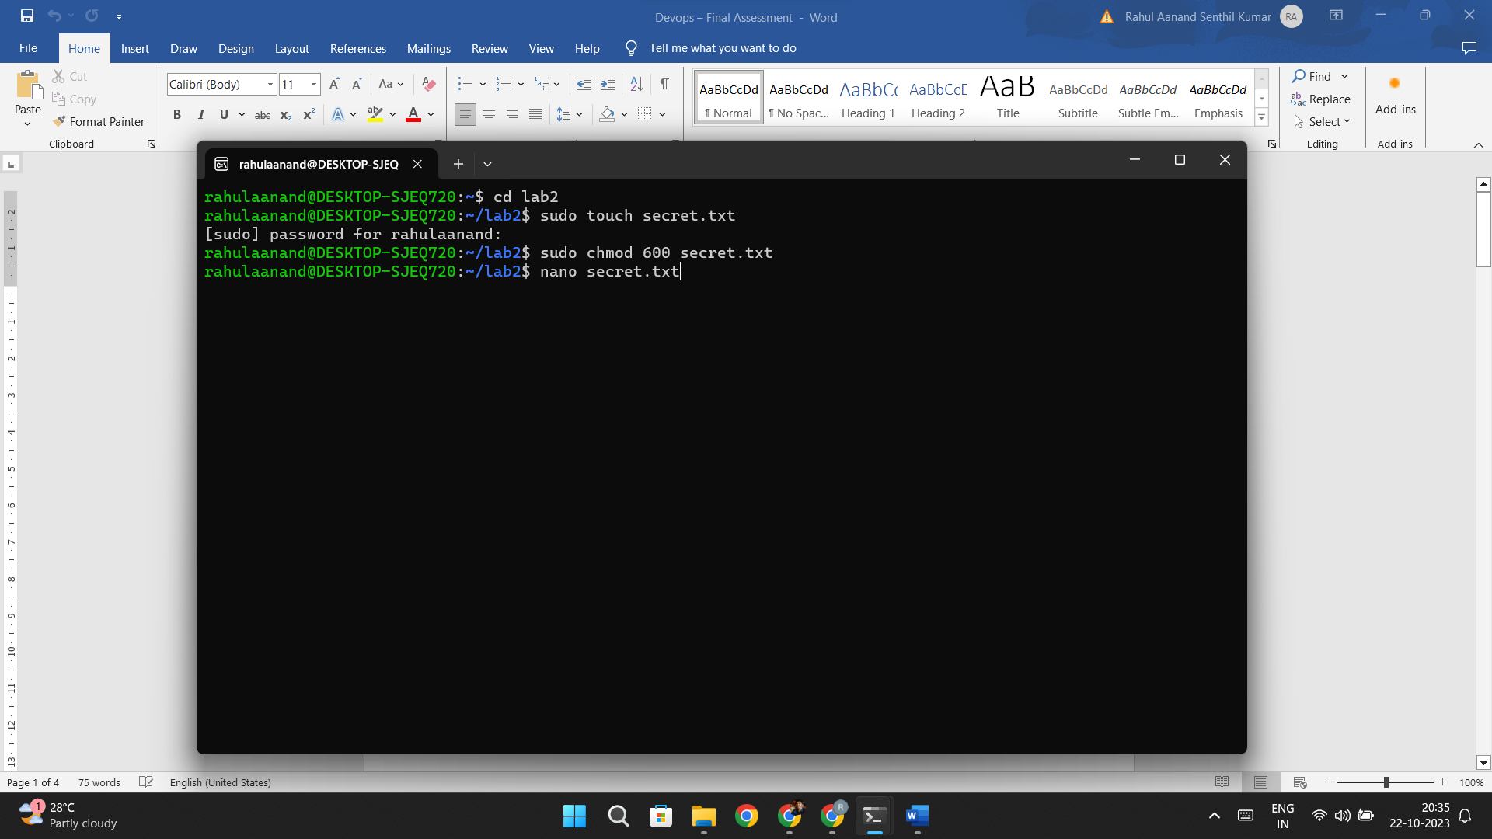

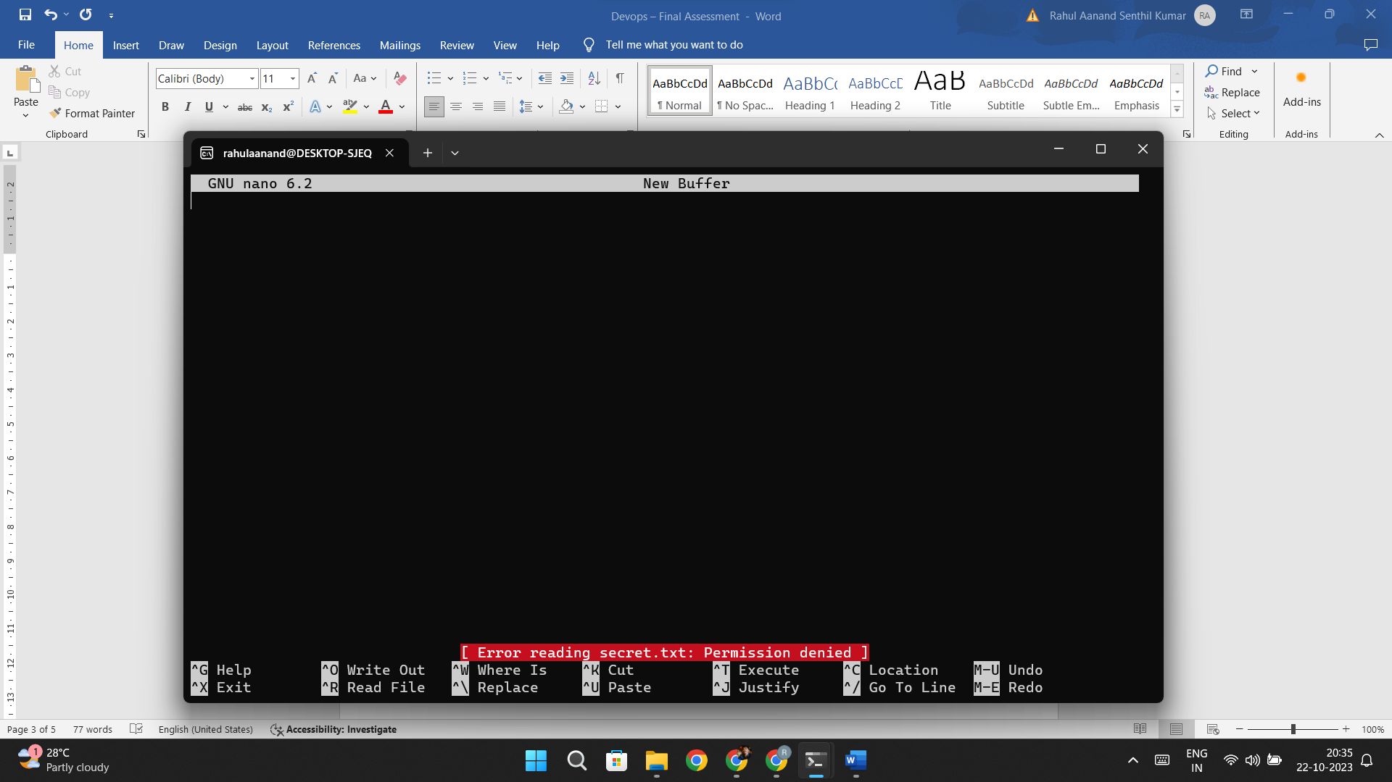

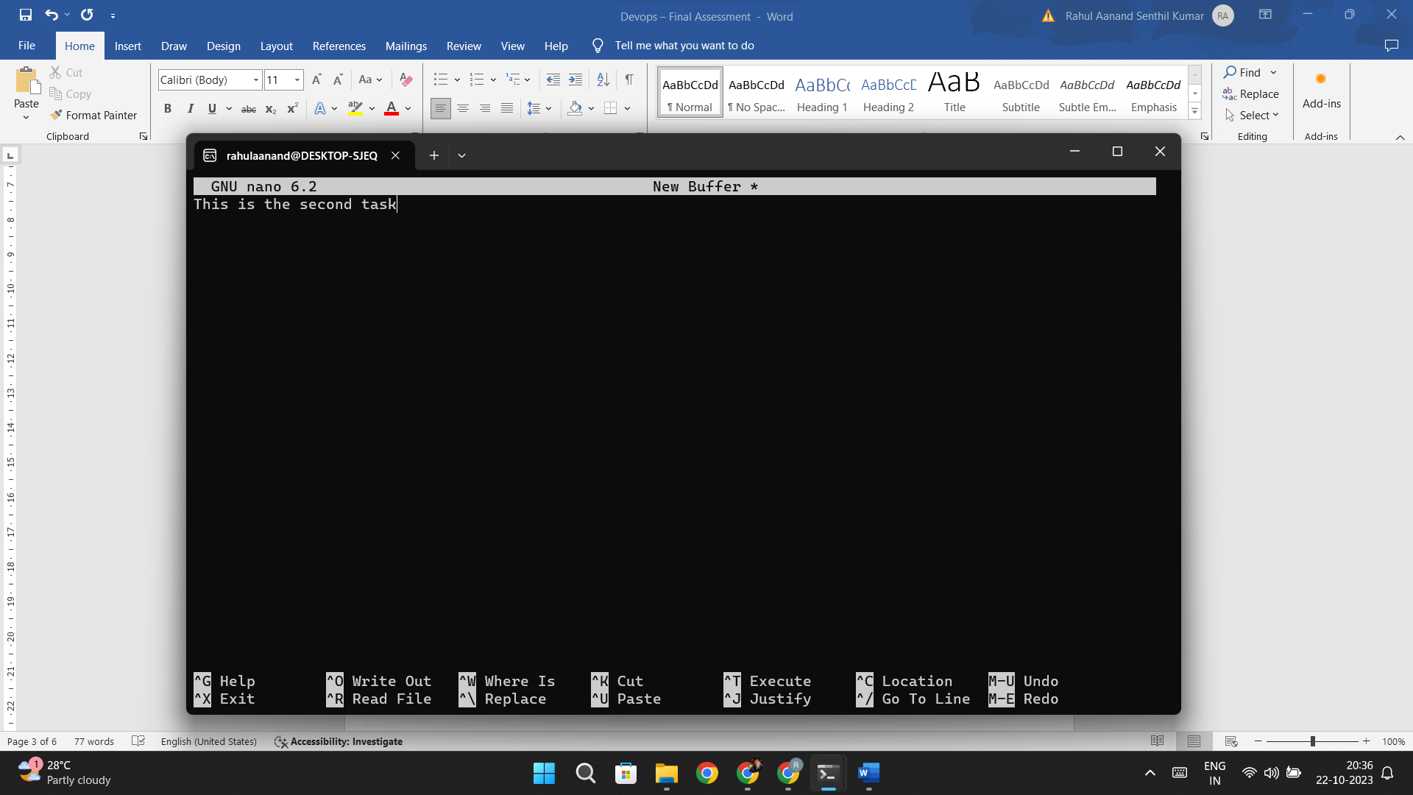

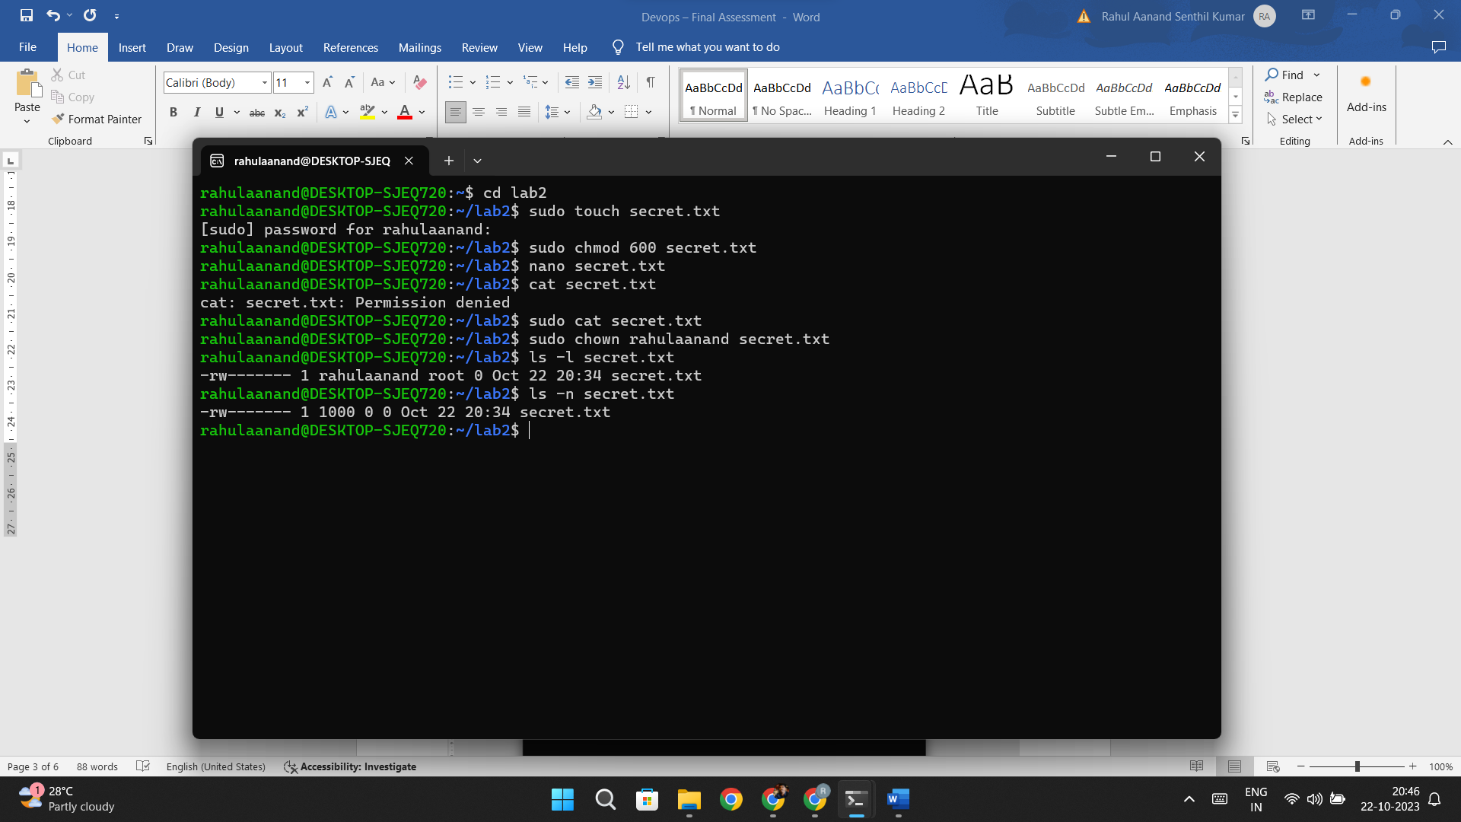

Lab 7: Create Classic Azure CI Pipeline for Angular Application

Objective: Set up a classic Azure CI pipeline to build a simple Angular application with unit testing using Jasmine and Karma.

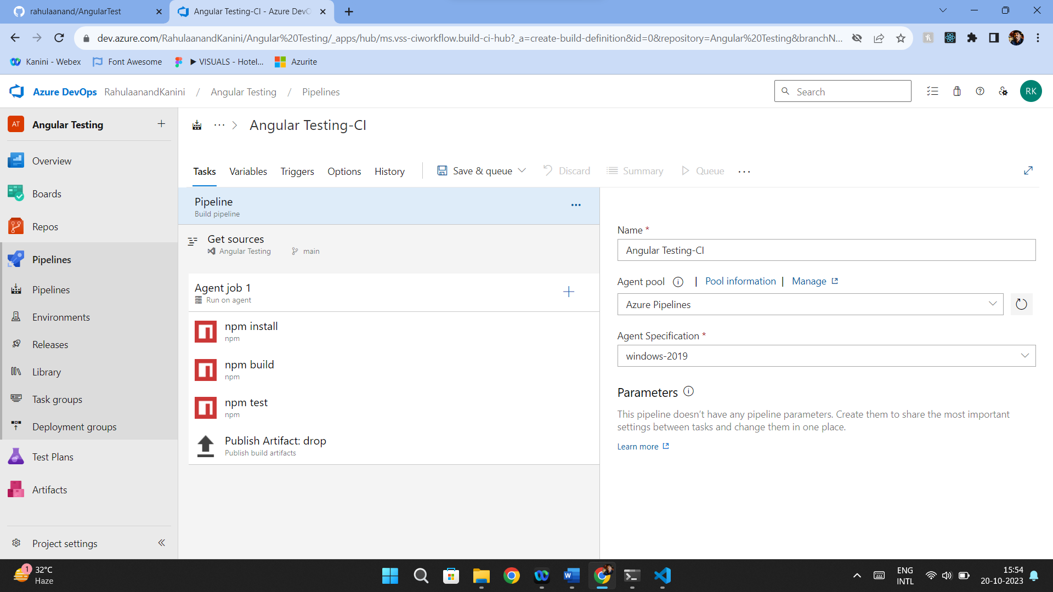

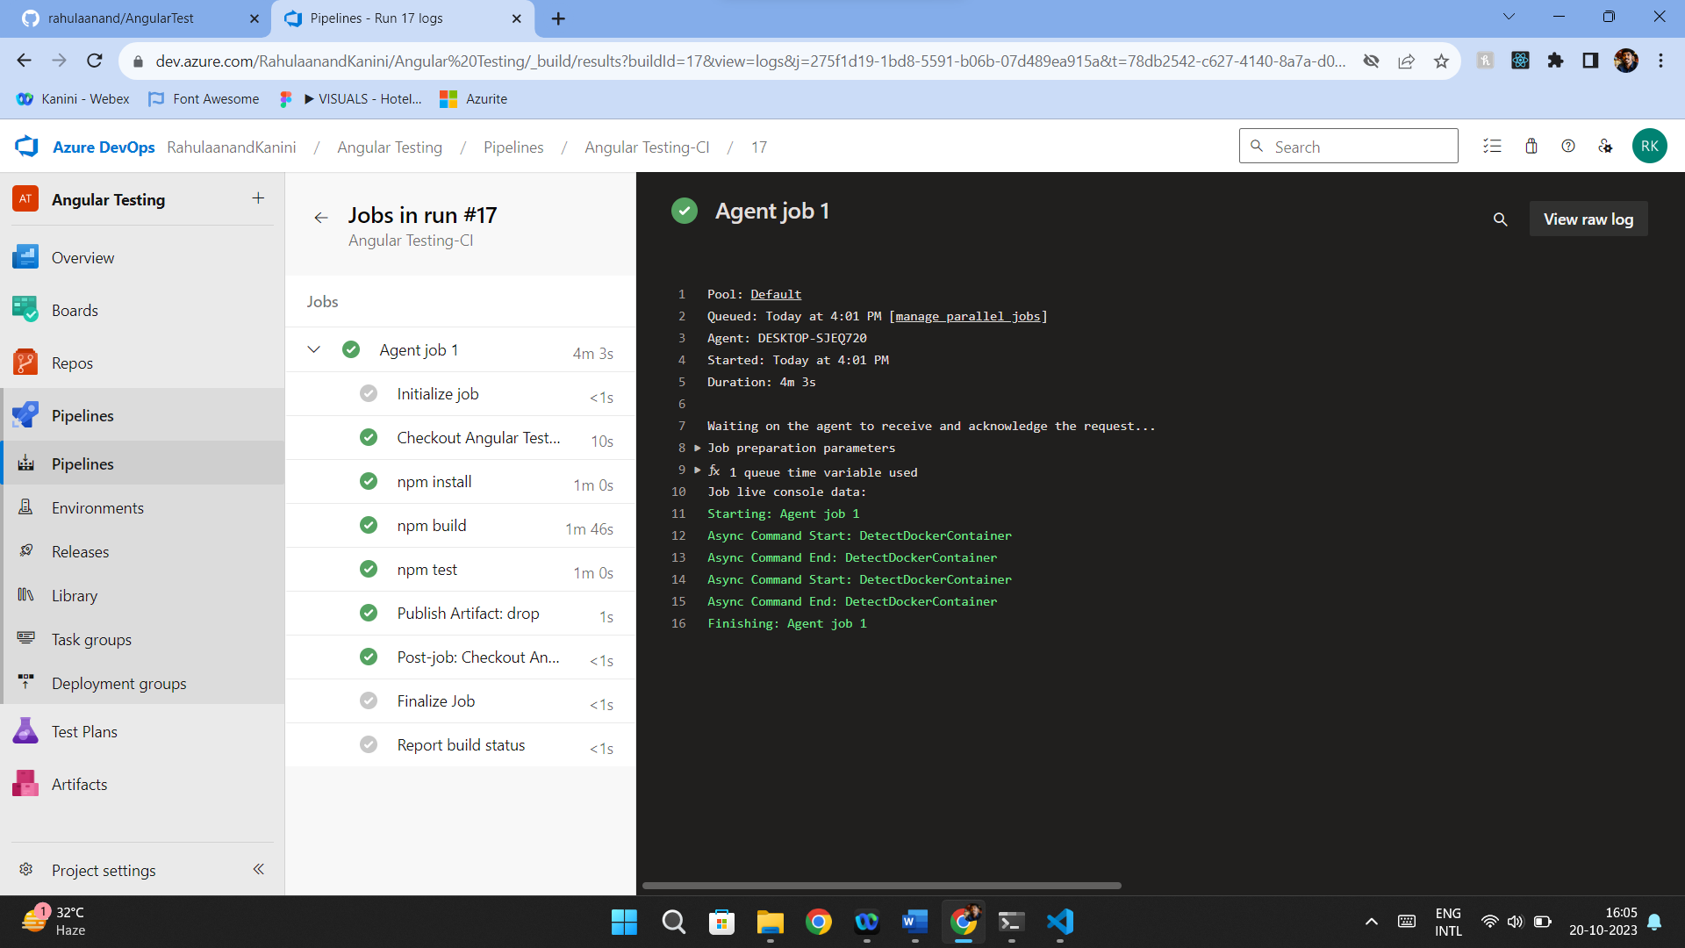

Lab 8: Create YAML Azure CI Pipeline for React Application

Objective: Create a YAML-based Azure CI pipeline to build a simple React application with unit testing using Enzyme and Jest.

